23.33: a) The electron will exhibit simple harmonic motion for 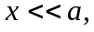 but will otherwise oscillate between 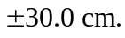
b) From Example 23.11,
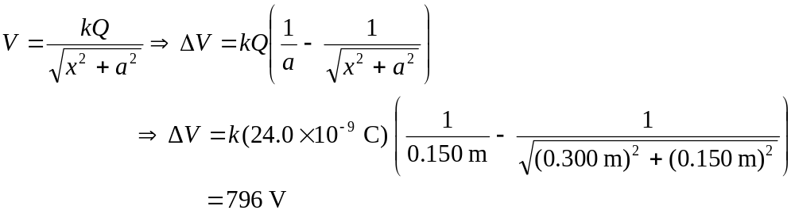
But 